Integrated Math 2 - Mixed Topics - Study Guide Name___________________________
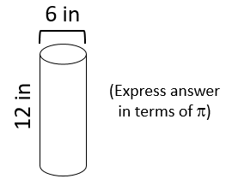
Find the surface area of each object.
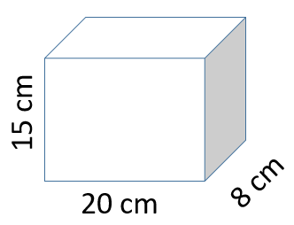
1) 2)

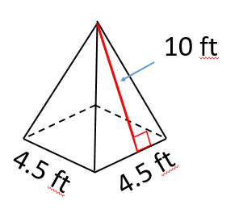
3) 4)
A sphere has a radius of millimeters. What is the surface area of the sphere? Express answer in terms of π.

5) The surface area of a cylinder is 300 square inches. If the radius is five inches, what is the height of the cylinder?

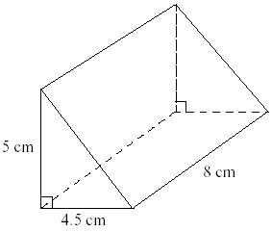
Find the volume of each object.
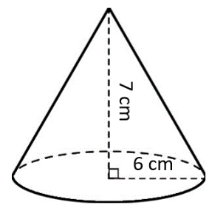
6) 7)

8) A box with a square base and rectangular sides has a height of 16 inches. If it's volume is 576 cubic inches, what is the length of the sides of the base? What is the length of the diagonal of the base?

Rewrite each radical expression with rational (fraction) exponents.
9) $\sqrt[5]{j^{3}}$ 10) $\sqrt[3]{7a^{2}b^{4}}$ 11) $5\sqrt{w^{7}}$

Rewrite each expression as a radical.
12) ${\left(3y\right)}^{\frac{1}{4}}$ 13) $9t^{\frac{3}{5}}$ 14) $a^{\frac{4}{3}}b^{\frac{1}{3}}c^{\frac{2}{3}}$

15) Walter was using rational exponents to simplify a radical expression, but he made a mistake. Circle the step where his mistake is and correctly finish the problem from there.
Walter's work: $\sqrt{x}∙\sqrt[3]{x}$
$x^{\frac{1}{2}}∙x^{\frac{1}{3}}$
$x^{\frac{1}{2 }+ \frac{1}{3}}$
$x^{\frac{1}{5}}$
$\sqrt[5]{x}$

16) Kyrstin was using rational exponents to simplify a radical expression, but she made a mistake. Circle the step where her mistake is and correctly finish the problem from there.
Kyrstin's work: $\sqrt[3]{\sqrt[4]{x^{2}}}$
$\sqrt[3]{x^{\frac{2}{4}}}$
$\sqrt[3]{x^{\frac{1}{2}}}$
${\left(x^{\frac{1}{2}}\right)}^{\frac{1}{3}}$
$x^{\frac{1}{2} + \frac{1}{3}}$
$x^{\frac{3}{6}+\frac{2}{6}}$
$x^{\frac{5}{6}}$
$\sqrt[6]{x^{5}}$

17) Simplify ${64}^{\frac{2}{3}}$. 18) Use rational exponents to simplify $\sqrt[5]{j}∙\sqrt{j}$

19) Consider the piecewise function $h\left(x\right)=\left\{ \begin{aligned}3x+2 , x<-2 \\ -4 , -2≤x<3 \\ 5-x , x≥3 \end{aligned}\right.$
$$h\left(2\right)=_____ h\left(-10\right)=_____ h\left(3\right)=_____$$
20) Graph the piecewise function.
$f\left(x\right)=\left\{\begin{aligned} \frac{2}{3}x+4 if x<3 \\ -2x-1 if x≥3\end{aligned}\right.$

21) Write the piecewise equation for the graph below.
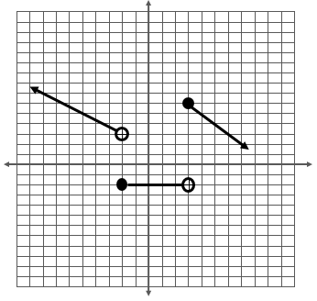

$f\left(x\right)=\left\{\begin{aligned} if \\ if \\ if \end{aligned}\right.$

Graph the exponential functions. LABEL the three key points for each graph.
22) $y=4({3)}^{x}$ 23) $y=5({2)}^{x-3}$ 24) $y={\left(\frac{1}{3}\right)}^{-2x}-1$

25) Dante buys a refrigerator for $2000. He later learns that the value of that refrigerator depreciates at a rate of 13% per year. How much will Dante's refrigerator be worth in five years?

26) The half-life of Ridiculum is four days. If you start out with 13.2 kg of Ridiculum, how much will you have after sixteen days?

After 22 days?

After how many days will there be no Ridiculum (0 kg) left?

27) Lola invests $400 in a startup company that promises to exhibit 40% growth (interest) each year. If this is the case, how much will Lola's investment be worth in 11 years?

28) Consider the equation $FV=2100{\left(0.79\right)}^{x}$ where x is the number of years.
Is this growth or decay?

What is the rate in this equation?

29) Write an expression equal to $x^{3}$ that includes…
…a squared. | …a fraction. | …a radical. | …a negative exponent.

30) Simplify each expression. Answers should contain no parentheses and only positive exponents.
$$x^{-4}$$ | $${\left(a^{4}b^{2}\right)}^{3}$$ | $$\frac{12x^{5}y^{-2}}{16x^{3}y^{2}}$$ | $$5a^{-2}b^{4}∙2a^{3}b$$ | $${\left(47x\right)}^{0}$$

